**NaPDI Repository Experiment Report**

**In Vivo Pharmacokinetics Experiment(s)**

**Please fill in all relevant fields to the experiment(s) performed.**

1. **General Information**

|  |  |
| --- | --- |
| **Title of experiment** |  |
| **Research organization** |  |
| **Object** |  |
| **Object therapeutic class** |  |
| **Measured object constituent(s)** |  |
| **Measured object constituent(s) metabolite(s)** |  |
| **Additional information** |  |

1. **Experimental Conditions**

|  |  |
| --- | --- |
| **Study design** | Single dosing  Multiple dosing |
| **Study Population - demographics** | Males  Females  Healthy volunteers  Patients |
| **Study Population – lifestyle factors** | Nonsmokers  Smokers  No alcohol drinking  Healthy alcohol drinking  Unhealthy alcohol drinking  No marijuana use  Occasional marijuana use  Regular marijuana use |
| **Study Population - ethnicity** | Not Hispanic or Latino  Hispanic or Latino  American Indian or Alaska native  Asian  Native Hawaiian or Other Pacific Islander  Black or African American  White  More than one race |
| **Study population genotype** |  |
| **Study population phenotype** |  |
| **Number of subjects (enrolled and completed the study)** |  |
| **Additional study population information** |  |
| **Times of PK samples for object** |  |
| **Object PK samples quality concerns** |  |
| **Additional general information** |  |

**An example of data entered in the repository on the admin side:**

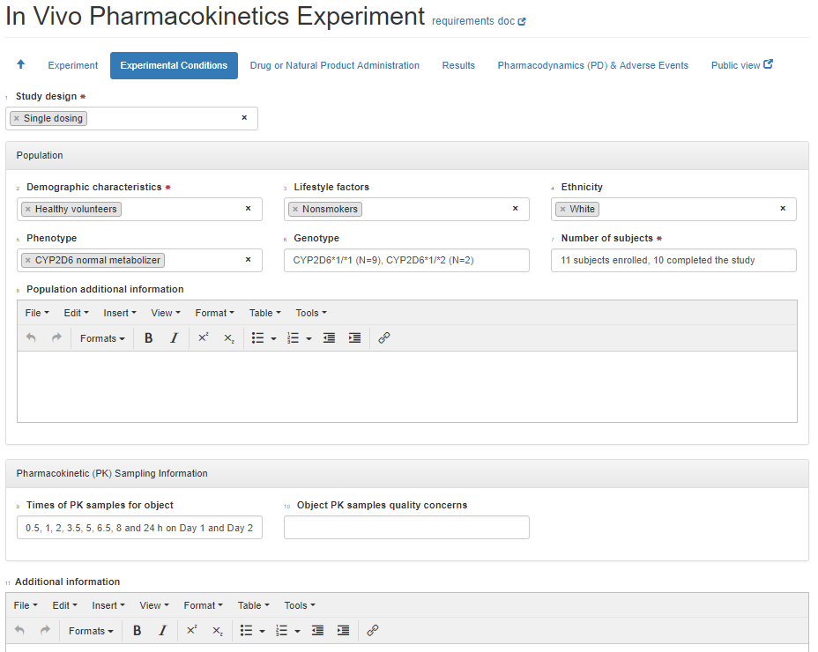

1. **Drug or Natural Product administration**

|  |  |
| --- | --- |
| **Administration route** | Oral  Intravenous  Transdermal  Intramuscular  Inhalation |
| **Prandial state** | Fasted  Fed |
| **Prandial state- additional information** |  |
| **Formulation** |  |
| **Total daily dose** |  |
| **Interval/frequency** |  |
| **Duration** |  |
| **Natural Product Manufacturer/source (lot number)** |  |
| **Natural Product Characterization by NaPDI analytical core?** | No  Yes  Yes, data attached to submission form |
| **Year sourcing was completed** |  |
| **Natural Product additional information** |  |

**An example of data entered in the repository on the admin side:**

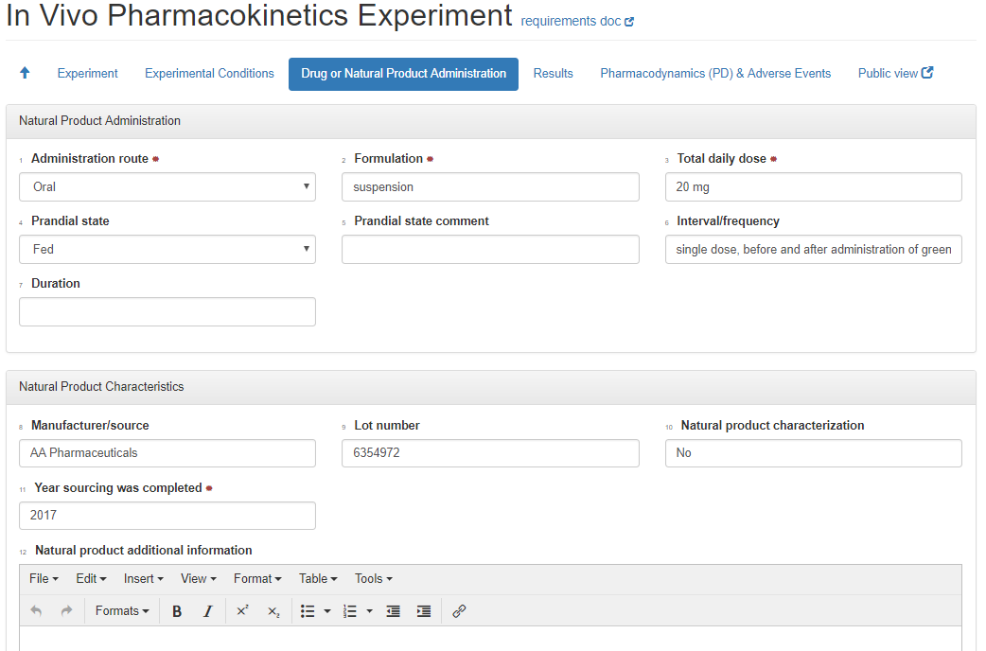

1. **Pharmacodynamics and Adverse Events**

|  |  |
| --- | --- |
| **Pharmacodynamic protocol** |  |
| **Pharmacodynamic classes** |  |
| **Pharmacodynamic result** |  |
| **Adverse event classes** |  |
| **Safety results** |  |

1. **Results and conclusions**

|  |  |  |  |  |
| --- | --- | --- | --- | --- |
| **Object or metabolite measured** | **Pharmacokinetic measurements**  **(see appendix I for list of PK measurements)** | **Value Type**  **(see appendix II for list of value types)** | **Value** | **Study sequence** |
|  |  |  |  | Control  Test |
|  |  |  |  | Control  Test |
|  |  |  |  | Control  Test |

(Add more rows if needed)

|  |  |
| --- | --- |
| Compartmental modeling parameters |  |
| Additional Information |  |
| Conclusion |  |

**Attach relevant figures and tables of results when submitting this form.**

**Appendix I:** **Proposed List of PK Measurements**

AUCTau

AUC(0-infinity)

AUC(0-tn)

AUC(0-t)* \**define t (T): 4, 24, 48 hrs…*

AUC ratio (metabolite/parent)

AUC ratio (parent/metabolite)

C (plasma)* \**define t (T): 4, 24, 48 hrs…*

C ratio (metabolite/parent) * \**define t (T): 4, 24, 48 hrs…*

C ratio (parent/metabolite) * \**define t (T): 4, 24, 48 hrs…*

CL(renal)

CL/F

Cmax

Css avg

Css trough

Fraction bound in plasma

Fraction unbound in plasma

Half-life (terminal)

MRT

Tmax

Cumulative Urinary Excretion (% Dose)

Urinary molar ratio (metabolite/parent) * \**define Total Collection Time (T): 24, 48 hrs…*

Urinary molar ratio (parent/metabolite) * \**define Total Collection Time (T): 24, 48 hrs…*

Vd/F

**Appendix II: List of value types**

* Mean
* Mean ± SD
* Mean ± SEM
* Mean (range)
* Mean (CV%)
* Mean (CI)
* Median
* Median (CV%)
* Median (range)
* Median (CI)